A Binary Search Tree (BST) is a tree in which all the nodes follow the below-mentioned properties −

* The left sub-tree of a node has a key less than or equal to its parent node's key.
* The right sub-tree of a node has a key greater than to its parent node's key.

Thus, BST divides all its sub-trees into two segments; the left sub-tree and the right sub-tree and can be defined as −

left_subtree (keys) ≤ node (key) ≤ right_subtree (keys)

Representation

BST is a collection of nodes arranged in a way where they maintain BST properties. Each node has a key and an associated value. While searching, the desired key is compared to the keys in BST and if found, the associated value is retrieved.

Following is a pictorial representation of BST −

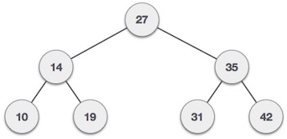

We observe that the root node key (27) has all less-valued keys on the left sub-tree and the higher valued keys on the right sub-tree.

Basic Operations

Following are the basic operations of a tree −

* **Search** − Searches an element in a tree.
* **Insert** − Inserts an element in a tree.
* **Pre-order Traversal** − Traverses a tree in a pre-order manner.
* **In-order Traversal** − Traverses a tree in an in-order manner.
* **Post-order Traversal** − Traverses a tree in a post-order manner.

Node

Define a node having some data, references to its left and right child nodes.

struct node {

int data;

struct node *leftChild;

struct node *rightChild;

};

Search Operation

Whenever an element is to be searched, start searching from the root node. Then if the data is less than the key value, search for the element in the left subtree. Otherwise, search for the element in the right subtree. Follow the same algorithm for each node.

Algorithm

struct node* search(int data){

struct node *current = root;

printf("Visiting elements: ");

while(current->data != data){

if(current != NULL) {

printf("%d ",current->data);

//go to left tree

if(current->data > data){

current = current->leftChild;

} //else go to right tree

else {

current = current->rightChild;

}

//not found

if(current == NULL){

return NULL;

}

}

}

return current;

}

Insert Operation

Whenever an element is to be inserted, first locate its proper location. Start searching from the root node, then if the data is less than the key value, search for the empty location in the left subtree and insert the data. Otherwise, search for the empty location in the right subtree and insert the data.

Algorithm

void insert(int data) {

struct node *tempNode = (struct node*) malloc(sizeof(struct node));

struct node *current;

struct node *parent;

tempNode->data = data;

tempNode->leftChild = NULL;

tempNode->rightChild = NULL;

//if tree is empty

if(root == NULL) {

root = tempNode;

} else {

current = root;

parent = NULL;

while(1) {

parent = current;

//go to left of the tree

if(data < parent->data) {

current = current->leftChild;

//insert to the left

if(current == NULL) {

parent->leftChild = tempNode;

return;

}

} //go to right of the tree

else {

current = current->rightChild;

//insert to the right

if(current == NULL) {

parent->rightChild = tempNode;

return;

}

}

}

}

}

What if the input to binary search tree comes in a sorted (ascending or descending) manner? It will then look like this −

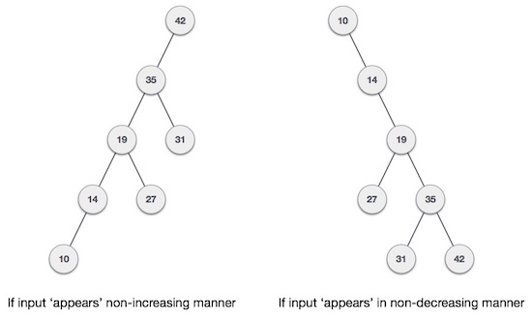

It is observed that BST's worst-case performance is closest to linear search algorithms, that is Ο(n). In real-time data, we cannot predict data pattern and their frequencies. So, a need arises to balance out the existing BST.

Named after their inventor **Adelson**, **Velski** & **Landis**, **AVL trees** are height balancing binary search tree. AVL tree checks the height of the left and the right sub-trees and assures that the difference is not more than 1. This difference is called the **Balance Factor**.

Here we see that the first tree is balanced and the next two trees are not balanced −

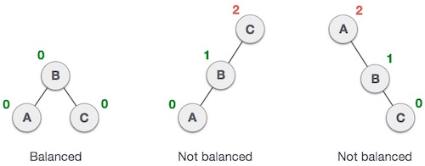

In the second tree, the left subtree of **C** has height 2 and the right subtree has height 0, so the difference is 2. In the third tree, the right subtree of **A** has height 2 and the left is missing, so it is 0, and the difference is 2 again. AVL tree permits difference (balance factor) to be only 1.

***BalanceFactor*** = height(left-sutree) − height(right-sutree)

If the difference in the height of left and right sub-trees is more than 1, the tree is balanced using some rotation techniques.

AVL Rotations

To balance itself, an AVL tree may perform the following four kinds of rotations −

* Left rotation
* Right rotation
* Left-Right rotation
* Right-Left rotation

The first two rotations are single rotations and the next two rotations are double rotations. To have an unbalanced tree, we at least need a tree of height 2. With this simple tree, let's understand them one by one.

Left Rotation

If a tree becomes unbalanced, when a node is inserted into the right subtree of the right subtree, then we perform a single left rotation −

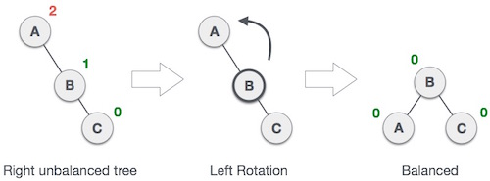

In our example, node **A** has become unbalanced as a node is inserted in the right subtree of A's right subtree. We perform the left rotation by making **A**the left-subtree of B.

Right Rotation

AVL tree may become unbalanced, if a node is inserted in the left subtree of the left subtree. The tree then needs a right rotation.

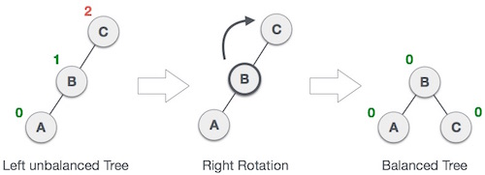

As depicted, the unbalanced node becomes the right child of its left child by performing a right rotation.

Left-Right Rotation

Double rotations are slightly complex version of already explained versions of rotations. To understand them better, we should take note of each action performed while rotation. Let's first check how to perform Left-Right rotation. A left-right rotation is a combination of left rotation followed by right rotation.

|  |  |
| --- | --- |
| **State** | **Action** |
| Right Rotation | A node has been inserted into the right subtree of the left subtree. This makes **C** an unbalanced node. These scenarios cause AVL tree to perform left-right rotation. |
| Left Rotation | We first perform the left rotation on the left subtree of **C**. This makes **A**, the left subtree of **B**. |
| Left Rotation | Node **C** is still unbalanced, however now, it is because of the left-subtree of the left-subtree. |
| Right Rotation | We shall now right-rotate the tree, making **B** the new root node of this subtree. **C** now becomes the right subtree of its own left subtree. |
| Balanced Avl Tree | The tree is now balanced. |

Right-Left Rotation

The second type of double rotation is Right-Left Rotation. It is a combination of right rotation followed by left rotation.

|  |  |
| --- | --- |
| **State** | **Action** |
| Left Subtree of Right Subtree | A node has been inserted into the left subtree of the right subtree. This makes **A**, an unbalanced node with balance factor 2. |
| Subtree Right Rotation | First, we perform the right rotation along **C** node, making **C** the right subtree of its own left subtree **B**. Now, **B** becomes the right subtree of **A**. |
| Right Unbalanced Tree | Node **A** is still unbalanced because of the right subtree of its right subtree and requires a left rotation. |
| Left Rotation | A left rotation is performed by making **B** the new root node of the subtree. **A** becomes the left subtree of its right subtree **B**. |
| Balanced AVL Tree | The tree is now balanced. |